Salesforce Developer Bridge Program – Day 6
Apex Triggers and Event-Driven Automation
Name: Golla Vaishnavi
Register No: 23PA1A0572
Date: July 2026

Objective
This sprint focused on understanding how Salesforce applications react automatically to business events through Apex Triggers. I explored why automation matters, what triggers business events, and how Triggers collaborate with service classes to keep enterprise applications clean and maintainable.

Topics Covered
- Event-Driven Software
- Apex Triggers
- Business Events
- Before and After Triggers
- Trigger Architecture
- Service Classes
- Automation Design
- Notification Services
- Placement Management System Automation

Understanding Automation
A well-built enterprise system should never rely on a user remembering to perform every step manually.
For example:
- Sending emails
- Updating placement status
- Refreshing reports
- Updating dashboards
These activities should happen automatically whenever an important business event occurs.
Automation helps reduce:
- Human errors
- Manual work
- Missed activities
- Administrative effort

What is a Business Event?
A business event occurs whenever important information changes in the system.
Examples:
- A student registers.
- A company creates a job posting.
- A student submits an application.
- A recruiter updates application status.
- A student accepts an offer.
When these events occur, Salesforce can automatically perform actions using Triggers.

What is an Apex Trigger?
An Apex Trigger is a block of Apex code that fires automatically whenever a specific event happens on a Salesforce record, such as an insert or an update.
Triggers help the system respond automatically to business changes.
Examples
- Validate applications before saving.
- Send notifications after updates.
- Update placement statistics.
- Create related records automatically.

Trigger Responsibility vs Service Responsibility
Trigger Responsibilities
- Detect business events.
- Notify the appropriate service class.
- Keep automation organized.
Service Responsibilities
- Execute business logic.
- Perform validations.
- Send notifications.
- Update records.
- Process business rules.
Key Learning
Triggers should observe events, not contain all business logic.

Understanding Trigger Timing
Before Trigger
Runs before the record is saved.
Used for:
- Eligibility validation
- Duplicate checking
- Data validation
After Trigger
Runs after the record is saved.
Used for:
- Sending emails
- Updating dashboards
- Creating related records
- Recording audit information

Placement Management System Scenario
Business Requirement
Whenever a student submits an application:
- Validate eligibility.
- Prevent duplicate applications.
- Save the application.
- Notify the Placement Office.
Instead of placing all logic inside the Trigger, the Trigger should call ApplicationService.
Workflow
Application Created
↓
Trigger Detects Event
↓
ApplicationService Validates Data
↓
Application Saved
↓
Notification Sent

Sprint Activities
Sprint 13 – Responding to a New Application
Built a Trigger, StudentJobApplicationTrigger, that fires whenever a new Application record is created and again when an existing one is updated.
The Trigger delegates validation responsibilities to the ApplicationService.
Learning
- Triggers should remain simple.
- Business logic belongs in service classes.
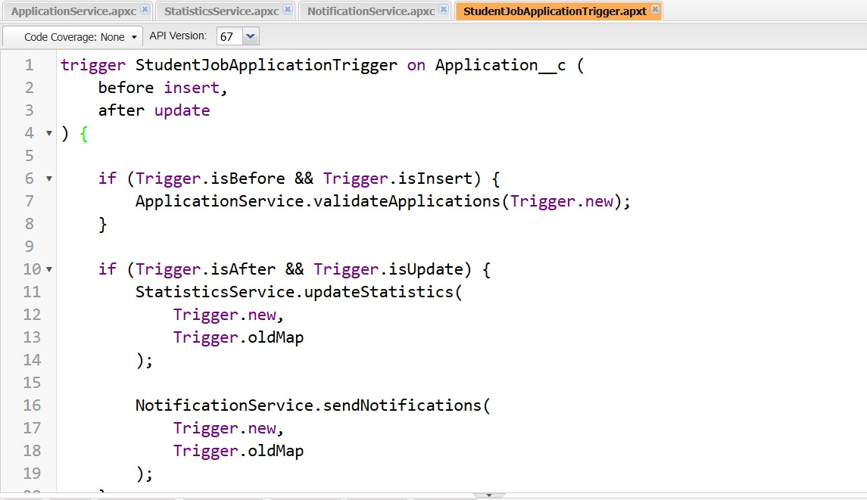
Figure 1: StudentJobApplicationTrigger delegating to service classes

Sprint 14 – Updating Placement Statistics
Whenever an Application status changes to Selected, placement statistics should update automatically.
A StatisticsService can be used to manage calculations and reporting.
Learning
- Reports and statistics should be handled separately.
- Good architecture supports future enhancements.

Sprint 15 – Sending Notifications
Important placement events may require notifications.
Examples:
- Interview Scheduled
- Selected
- Rejected
- Offer Accepted
A NotificationService can manage communication activities.
Learning
- Notification logic should be centralized.
- Avoid duplicate email logic in multiple locations.

Sprint 16 – Preparing for Future Requirements
The Placement Office requested additional automation.
Example:
Whenever a student accepts an offer, the Alumni Office should receive the student's details.
Instead of modifying the Trigger heavily, a new service can be added.
Learning
Good architecture allows new features to be added without affecting existing functionality.

Sprint 17 – Building a Reusable Student Service Layer
The Placement Office also needed a consistent way to look up a student’s profile – CGPA, branch, and active backlog count – whenever a record was opened from a related process.
Rather than repeating this query inside multiple Triggers and controllers, a StudentService class was created to centralize the logic.
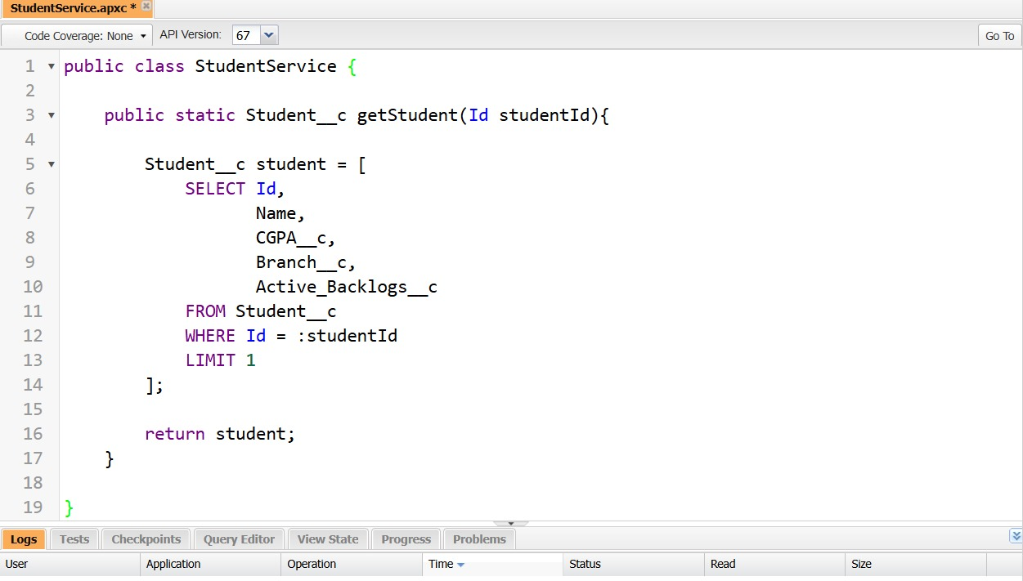
Figure 2: StudentService class retrieving a Student__c record
Learning
- Reusable queries belong in a dedicated service method, not scattered across Triggers.
- Testing queries directly in the Developer Console Query Editor helps confirm data shape before wiring up automation.
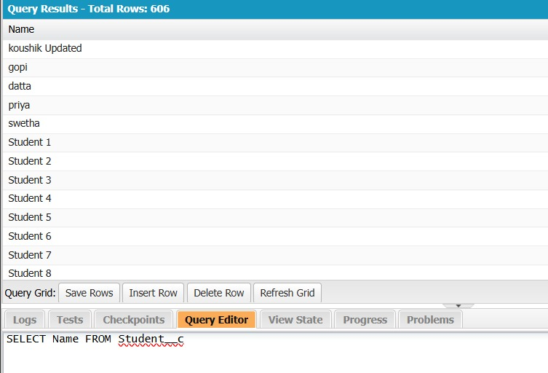
Figure 3: Query Editor results showing Student__c records

Engineering Principles Learned
Principle 1
Every Trigger begins with a business event.
Principle 2
Triggers should observe events, not make business decisions.
Principle 3
Business logic should remain inside Service Classes.
Principle 4
One component should have one responsibility.
Principle 5
Good architecture makes future changes easier.

Common Design Mistakes
Mistake 1
Placing all business logic inside the Trigger.
Problem
- Difficult to understand
- Difficult to maintain
- Difficult to debug

Mistake 2
Creating multiple Triggers on the same object.
Problem
- Confusing execution order
- Difficult troubleshooting

Mistake 3
Duplicating validation logic.
Problem
- Inconsistent behavior
- More maintenance effort

Mistake 4
Updating unrelated objects directly from a Trigger.
Problem
- Tight coupling
- Increased complexity

Interview Questions Practice
Why should business logic remain outside the Trigger?
Business logic should remain in service classes because it improves maintainability, readability, and reusability.
What should a Trigger do?
A Trigger should only detect business events and delegate processing to service classes.
Why use Service Classes?
Service classes separate responsibilities and make the system easier to maintain.
Why is good Trigger design important?
Good Trigger design improves scalability, readability, and future enhancements.
How does good architecture help new developers?
New developers can quickly understand responsibilities and locate business logic.

Challenges Faced
- Understanding the difference between Trigger logic and Service logic.
- Identifying appropriate Before and After Trigger scenarios.
- Designing automation without placing everything inside the Trigger.
- Thinking about long-term maintainability.

Skills Gained
- Apex Trigger Fundamentals
- Event-Driven Automation
- Trigger Architecture
- Before and After Trigger Concepts
- Service Layer Design
- Business Event Analysis
- Enterprise Application Design
- Salesforce Best Practices

Conclusion
Through this sprint, I gained a clearer understanding of how Apex Triggers let Salesforce applications react automatically to business events. I learned that Triggers work best when kept lightweight, leaving the actual business logic to dedicated service classes such as ApplicationService, StatisticsService, NotificationService, and StudentService. This layered approach makes the system easier to maintain, scale, and extend as new business requirements arise.

